**Hylux Vitamin Enhanced Water: Finding Distribution**

**Abstract**

Lamar Letts, an undergraduate student at Northeastern University in Boston, had developed a vitamin water drink in response to his own needs as a high school student athlete in Brooklyn, NY. Lamar had developed heart disease and, after recovery, could not use the vitamin waters that were on the market. He developed a better tasting, lower calorie alternative. The challenge he had been facing for the last couple of years was how to break into distribution. One of the toughest challenges for an entrepreneur with a new product was trying to get retail shelf space. Lamar had been successful in getting his product on the shelf in several retail outlets that he could service directly himself. What he was having difficulty with, however, was finding wholesalers that could expand his distribution. He was in a catch-22, retailers were not interested until he had wholesalers, while wholesalers were uninterested until he had retail traction. In 2017, Lamar had finally found a midlevel wholesaler who was interested in carrying his product. Lamar realized that if he did sign with the wholesaler that he would need to scale his company quickly, which most likely would require raising money. Lamar had to decide whether he was ready to change his organization to take advantage of his multiyear effort to find wholesalers.

**Learning Objectives**

1. Investigating how designing to one’s own pain points is a legitimate new product development approach
2. Understanding the various approaches to distribution and the challenges for each type
3. Analyzing the interaction of segmentation and distribution alternatives
4. Analyzing the challenges in finding wholesalers and retailers for a new product as a startup
5. Discussing the need to raise money to acquire scale

**Introduction**

I think I can finally break through the Catch-22 of getting a larger distributor. The distributor, Atlas, and I seemed to hit it off because he asked where I’ll take the brand and do I have the drive, being so young. Normally I’m asked if I have investors and if I am certified to be carried in chain stores. But the chain stores ask if I have distributors, and investors want to see that I have distributors and retailers. I’ve spent three years trying to break in, and I may finally be at the door. But if I go through the door, my business is going to change completely.

Lamar Letts, the founder of a Hylux, a sports drink, was working on the numbers he was going to present to the potential distributor in Central Massachusetts. Lamar was a senior in Finance and Marketing at Northeastern University in Boston. He had been working on his company since freshman year, when he recalled his thinking at the time, “It’ll take 4 months to launch the company.” But it actually took 2 years to develop the product that he introduced in 2014, and in 2017 he was still trying to develop his distribution.

Lamar was born in Brooklyn, NY where his parents owned 2 Jamaican restaurants, but grew up on Long Island. He got the idea for a light sports drink because he had been a high school athlete in track and football. An unexpected heart injury during Lamar’s senior year of high school caused him to question the current selection of functional beverages on the market and motivated him to create the perfect health beverage for himself and others. Immediately after his recovery from myocarditis, which was an inflammation of the heart muscle, Lamar was forced either to dilute traditional sports drinks or to create his own homemade sports drinks after workouts as an alternative to traditional sports drinks because he was not exercising at his previous level of intensity and could not afford to take in the extra calories and sugar. He always knew that there was a lack of hydration alternatives for health-conscious individuals; however, it was at this time that he realized the extent of the problem. “I always figured that someone would do it,” he said. But when he found no one had, he set out to make the perfect sports drink; one that would combine the lightness of water with the benefits of a sports drink.

Because Lamar’s parents had the two restaurants, he was able to get some contacts in the food industry. He contacted a food scientist, who was able to come up with a recipe for a light sports drink that had a nice taste. This cost Lamar $1000 per flavor. He decided to create three flavors because he had some money saved up for college - $3000. His first packaging consisted of a standard bottle, so he could save money. He was able to find a small co-packer in Brooklyn, New York who was able to do small production runs. He raised money from friends and family to invest in the first production run and was faced with how to sell what he had created.

Lamar decided to sell online. To save money, Lamar created three videos by writing the scripts himself, by casting the actors and by creating a web site. Lamar can laugh now but he recalled, “I launched and no one cared. I guess that is the right of passage for entrepreneurs. I realized I had to do the leg work and make them care.” Lamar still sold online, although it was not his main source of sales. The web site is: <https://drinkhylux.com/>

**The Early Days**

Lamar talked about his next steps. “I did not know how to make money in this business. I thought I would have to go out and sell every single store –I would have to negotiate with every store manager. I eventually learned about distributors.” Lamar began by going to grocery stores and trying to convince the managers to stock his product. The small independently-owned stores would buy but the large stores would not. “I did not know about ‘buyers’ in the chain stores. The managers would smile and say let us think about it, but you would never hear from them again,” he recalled. Lamar then decided that he would approach gyms and fitness centers as his targets in order to avoid the “shelf” competition that already existed in grocery stores. While still in school he would drive to 10 gyms a day in Boston. The reactions to his pitch provided market validation. Although he began to get some accounts, he discovered that servicing the accounts was a challenge. He could not do product tastings and deliveries in a timely fashion. He began to lose some of his early accounts.

Lamar did a Google search for distributors but found none existed for fitness centers. The available distribution channels were, in effect, requiring him to rethink his retail outlets. “My first distributors were small independent distributors in NY. They saw my product in some bodegas and in my parents’ restaurants and became interested.” Lamar found that his market became regionally different: in NY he had 2 small independent distributors and his outlets were all small independent stores. In Boston, he could not find any small distributors so his Boston market remained gyms that he had to service himself.

Because of the resistance he was facing from bigger distributors, Lamar decided he had to make some changes to improve his chances. He talked about the differences in the distributors he encountered.

Small distributors did not need to know the numbers because they knew you did not have any. They were betting on you having an interesting product that they could get in on early. The bigger distributors, however, were asking how big was your production, how much money did you have invested, what were your sales projections. They wanted to know that you were legitimate and that you were in it to win it, because they did not want to waste their time on you. Big companies can pour all sorts of money into an unproven product and get distribution. But the little guy cannot.

Lamar decided that one thing he could do to look more legitimate was to create a custom package that would allow higher quality branding. He raised $14,000 in a Kickstarter campaign and came up with much better packaging (see Figures 1-3). He also started rethinking his target geographies:

I wanted to be in gyms in NY, Chicago, and Los Angeles. But now I am finding that I have to go with small distributors in smaller markets to prove myself. I did not plan on Central Massachusetts but I have the opportunity there. I may have to think about smaller towns in the Midwest too. If I can get some smaller chains in the Midwest, then I can get some distributors. So it is opposite from what I thought – I need to get the retailers to get the distributors.

**Industry**

The functional beverage segment in the US was segmented into four main parts: (1) hydration, (2) energy/rejuvenation, (3) health & wellness and (4) weight management. The total US non-alcohol beverage market was valued at over $160 Billion dollars in 2016, and the functional beverages industry was approaching $20 Billion of that total. (All data taken from Hylux business plan). The functional beverage market had been showing steady growth over the last decade, however within the last couple of years there was a sharp rise, as the market was expected to grow in excess of 10% in 2016.

Consumers were navigating through food and beverage varieties with a greater breadth and depth of knowledge, as there appeared to be a cultural shift away from “health" and toward “quality of life," where consumers focused on positive and vital experiences, emotional wellness, new exercise techniques, complementary medicine and what they viewed as “clean, real foods" (Demeritt, Trends).

Competition in the functional beverage industry came from sports drinks such as Gatorade and Powerade, flavored waters such as VitaminWater and Sobe LifeWater, as well as from enhanced waters such as Essentia and Smart Water. These products competed with Hylux across the board, as they were beverages that were fortified and provided some sort of functional benefit to the consumer. Important indirect competitors in the area of fruit flavored beverages were brands such as Tropicana and Odwalla.

Lamar’s idea was to differentiate Hylux through the combination of its unique tasting blend, low calorie count, low sugar count, and the functional benefits of the formula, which were delivered by the vitamins and electrolytes that it provided. Hylux offered consistent vitamin and mineral content in each flavor, similar to how sports drinks like Gatorade did; however it also gave the light flavoring and health benefits that enhanced-water provided. This positioned Hylux to be a healthful combination of a sports drink and enhanced water. It had less sugar, fewer calories, and more vitamins and nutrients. The most important factors of the drink formulation were natural ingredients, color, taste, and functionality.

Hylux offered functional benefits similar to its direct competitors but without the extra calories and sugar while also containing the most vitamins and electrolytes. No other major competitor offered this level of vitamins and electrolytes. This was important because it spoke directly to the core health conscious consumer that Hylux targeted. Hylux and Hylux Water competed with each competitor in their own unique way. See Exhibit 1.

**Customers**

Lamar discussed his target market, “Our customers are men and women between 21 and 35 who are health oriented and conscious of their nutrition.” From surveys he found that these people have an education level greater than a high school education and may not pay the most attention to the fitness of their lifestyle. However, they are conscious of small decisions that can have an impact on their health. Even though they do not always do healthy things like drink water or eat healthily, they knew the benefits of it and made it a point to act on these healthy habits in some way, shape or form. Lamar added, “Our product is also catering to the needs of athletes who partake in any activity at any level of fitness. We see that individuals who are generally aware of the health benefits of proper hydration are attracted to the product.”

The current customers were gym patrons in the Boston area as well as regular gym goers and athletes at Northeastern University, and fitness-oriented consumers in New York that shopped in delis and convenience stores. What these groups had in common was that they acknowledged the need for daily intake of vitamins and electrolytes and felt that Hylux’s offerings were sufficient. Gym patrons were generally more interested in the exact benefits of the vitamins in Hylux and wanted to know what each one did to benefit them after a workout. Athletes and gym goers at Northeastern University were interested in the all-natural/no additive offerings as well as the light calorie load and vitamin and electrolyte offerings. Fitness-oriented consumers in New York were interested in the fact that Hylux had a great taste and had fewer calories and less sugar than Gatorade, Vitamin Water and other leading health drinks.

The primary target retailers were mainly specialty health & fitness stores such as gyms, bike shops and health clubs. These stores were deemed good places to sell due to the specialization of their staff and their “opinion setting,” ability in the health world. Many of these gyms did not buy Gatorade and other sugar-filled drinks because they recognized that they were not the healthiest options. These locations included Women’s Fitness of Boston, Fisique Fitness, Rock N’ Fitness, Zone 5 Fitness. By starting at local gyms, Lamar felt that Hylux could get proper exposure to its target market and eventually gain enough popularity to expand into larger regional franchises and gain space on the shelves of national health-related franchises such as GNC and Equinox.

Convenience stores and delis in New York and Boston were Hylux’s secondary target retailers. A local distribution deal in New York had allowed Lamar to reach out to health-conscious consumers who watched their weight and calorie intake. Hylux resonated with these consumers because it had less sugar, fewer calories and more vitamins than most competing fitness drinks. In Boston, small retailers such as Symphony Market and Wollaston’s allowed Lamar to reach the health - oriented consumers at Northeastern University. These students were on sports teams and/or were regular gym goers. These convenience stores carried many different and competing products. Lamar, however, felt, “Our superior health-based offerings and promotions directed to fitness-oriented students and consumers allow us to project our message and attract our target customers.”

**Products and Services**

Hylux came in two forms: unflavored and flavored. Being able to offer both allowed Lamar to be flexible in how he appealed to consumers, whether it was with a complete zero calorie enhanced water or a low calorie and low sugar flavored water. They were sold in 500ml (16.9 oz) bottles. Each bottle contained a series of vitamins, minerals and electrolytes that provided functional benefits to the consumer. The unflavored version was called Hylux Water and the flavored was called Hylux Sport. The flavored form had 3 fruit blends, which were kiwi-strawberry, lemon-lime and Berry Mix. The drinks were naturally flavored and naturally colored and were made in strict accordance to the guidelines set by the FDA in respect to its natural quality. Hylux was hot filled, which meant that it was heated to temperatures of over 185-194 degrees Fahrenheit before it was put into a bottle. This extended its shelf life to around 1 year and ensured its freshness. The packaging displayed images of the fruits that flavored the drink. The color and texture of the drink were visible through the bottle.

Lamar had found that in a gym setting individuals were more interested in Hylux Water. The bottle, therefore, was designed to make it easier to grip by being slightly taller but noticeably skinnier. In the convenience store setting, consumers responded better to the flavored version. There was some overlap though, as people in gyms did opt for the flavored drink and consumers in convenience stores did purchase the enhanced water. Lamar thought, “People who live an active lifestyle appreciate this choice because different workouts and activities call for different types of supplementation.”

The ingredients for the beverages were sourced in Amsterdam, New York, the labels were sourced in Chicago, and the bottles were sourced in Pennsylvania. Everything was sent to the co-packer, located in Brooklyn, New York. The product components were sourced from these firms and in these locations based off of their geographic proximity to Brooklyn and their rates.

Production took 1 week. When the ingredients got to the co-packer, they were mixed together in commercial kettles and then filled into bottles which came down an automated filling line. After they were filled, groups of 12 were packaged together with shrink wrap and stacked on a pallet. The co-packer did all of this and charged Lamar for use of their equipment. Lamar did not need to be present during production, however, he came in to watch production and to sample to insure quality

Lamar commented on outsourcing production:

Since production is outsourced to the co-packer, we do not need to invest in equipment, and only need to focus on storage, logistics, marketing and sales. After production we receive 6’ high pallets from the co-packer that we must truck to Boston or a different location in New York for eventual sale. The supply chain works because it is efficient and each member provides us with a quality product. With the way it is set up now, we can easily order the flavored water or the unflavored water and expect the same consistent quality and 1 week lead time. We have established positive relationships with our supply chain members and we have been given outlines of volume-based discounts that we can get as we increase our order sizes. We feel that being horizontally integrated is the best option for both price and quality at this moment.

The advantage Lamar had in using the small co-packer was that he was able to get small production runs. One large barrier that many smaller beverage companies faced were high minimum production requirements of co-packers. The disadvantage of using the small co-packer, however, was the inability to quickly ramp production if a big order came in.

In gyms Hylux retails at a premium of $1.99- $2.49. Convenience stores sell the beverage at $1.49 and $1.99. Lamar commented:

Customers have responded well to the prices in gyms, because they fall in line with the prices that they are used to seeing inside the gym. We have learned that these prices are stable in the gym environment, and product demos that push the benefits of the product further help keep the perceived values high. We have seen that the pricing in convenience stores aligns with competing products and has been working well for us. Most of our volume has been at the higher price point, so we take this as an indicator that the perceived value of the beverage matches the pricing. In the future when our production costs get lower, we will assess whether we should decrease prices of keep them the same. If customers still feel our product is worth the value and if competitors are still in that range, we will most likely keep prices the same.

The main form of customer acquisition was through product demos, which Lamar did by himself. Lamar thought this worked well, but he was capacity constrained – he could not handle any more accounts. The demos allowed Lamar to educate gym goers about the product and to build a community around it in the gyms. Gym managers and owners seemed to like this because it added a unique gym experience for their members by giving them something new to partake in inside the gym while also driving sales of the beverage.

Lamar estimated that he had spent about $5000 on web-based advertising through videos and his website. However, he thought that his efforts on video were not the most relevant to immediate sales. He commented, “The learning that we have had on the effectiveness of ads lets us know that there is room for more efficiency in marketing spending.”

**Decision**

To date, Lamar had sold over 12,000 bottles of Hylux, but he had reached his limit in directly handling retailers. Except for the two small wholesalers in NY, Lamar was the distribution system. But now Atlas distributors was willing to take a chance on him. Although excited by the opportunity, Lamar realized that servicing a mid-sized wholesaler would be difficult to manage. The wholesaler would want to be assured that Lamar could deliver enough product so that the wholesaler could service its accounts. It did not want to suffer stock outs and other issues with its retailers because Lamar could not service the wholesaler. Lamar’s current production and supply chain would have to be changed because his small batch mixer did not have the capacity. He would also have to raise money to be able to order the larger production runs, and he could no longer rely on his current friends and family to provide him enough money. This meant that Lamar would have to find investors and turn his company into a full-time business for himself. This is what he had wanted, but now he understood that he had to be sure he had a competitive product. He knew it worked in gyms and was competitive, but would it sell in retail outlets where it was going up against the big boys?

**Discussion Questions**

1. Analyze Lamar’s development of Hylux from the idea stage to product prototype.
2. What are the two main customer segments Lamar has determined? What are the implications for distribution depending on which segment he targets?
3. What are the challenges of a startup finding distribution? How does that compare to a big company when it introduces a new product?
4. What are some of the distribution outlets that are best suited for Lamar’s products? What are the different distribution alternatives Lamar has tried? Where is he being stymied and why?
5. Analyze how long it may take Lamar to raise money for his business. How would this impact his possible agreement with a midsized wholesaler?

**References**

Demeritt, retrieved from: https://www.forbes.com/sites/thehartmangroup/2015/11/19/consumer-trends-in-health-and-wellness/#7c3ff5ef313e

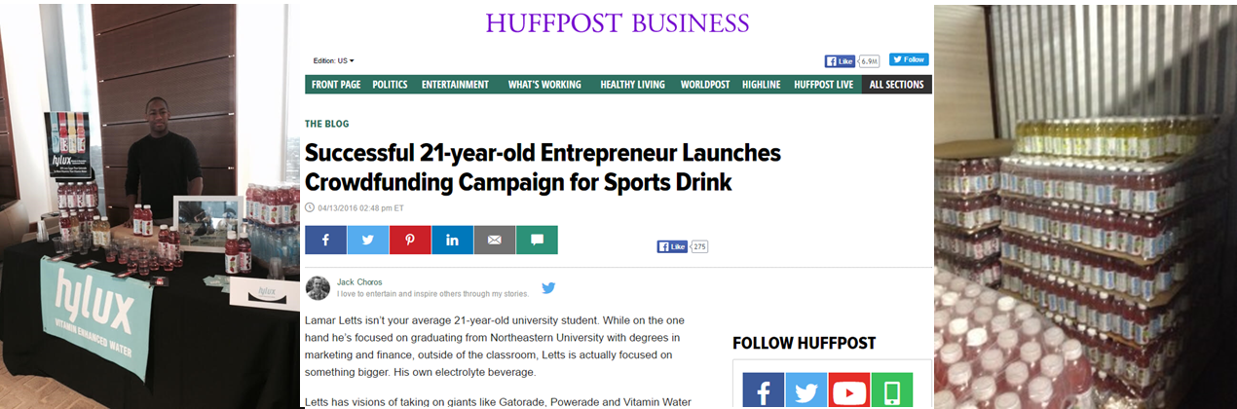

Figure 1: Lamar at a Tasting

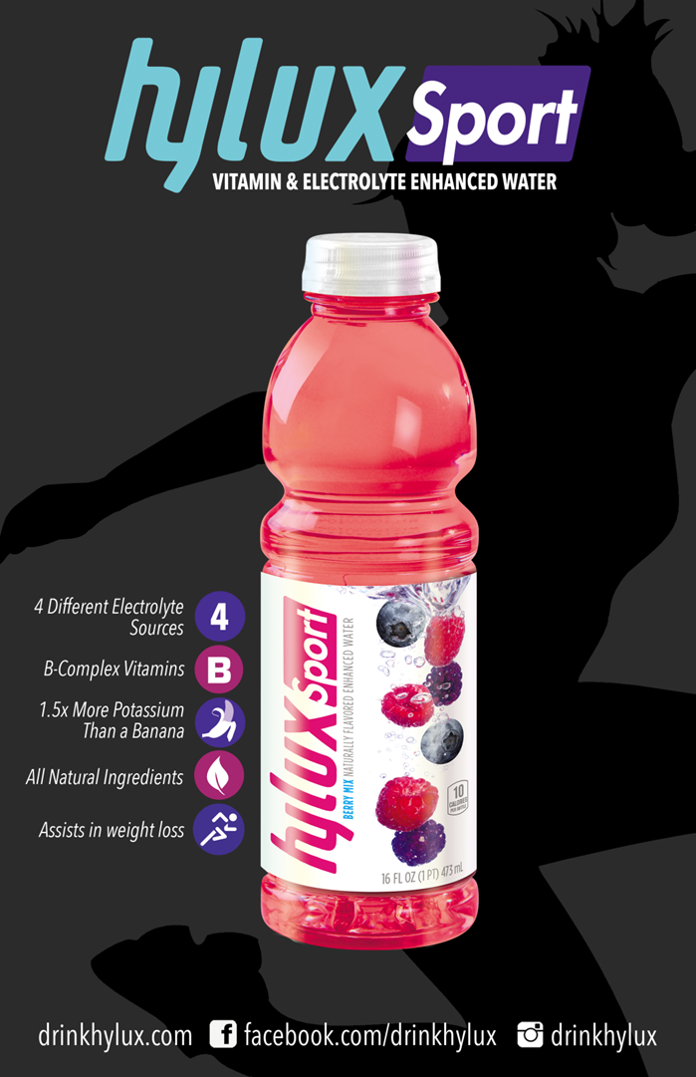

Figure 2: Original Bottle Design

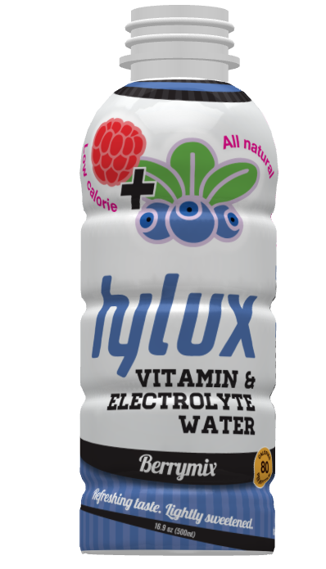

Figure 3: New Bottle Design

Exhibit 1

Hylux vs. Sports Drinks (Gatorade & Powerade)

Hylux Sport competes with sports drinks like Gatorade by offering more vitamins and electrolytes for a fraction of the calories. Gatorade provides high levels of sodium and sugar and a little potassium while Hylux provides less sodium, more potassium than a banana, B-vitamins, magnesium and is natural. Gatorade and other popular sports drinks use artificial ingredients.

Hylux Water competes by offering a sugarless functional beverage. Many consumers prefer to have only the nutritional benefits which are given to them in the unflavored version which is just water and electrolytes. When drinking an electrolyte water, consumers do not get the quantity of vitamins and minerals that is in Hylux or a sports drink however, this is true for all electrolyte water. It is mostly personal preference and the degree of health consciousness a person has.

Hylux vs. Flavored Water (Vitamin Water)

Hylux Sport competes with flavored waters such as Vitamin Water by offering consistent functional benefits similar but without the extra calories and sugar. Vitamin Water differentiates by offering different flavors that contain differing nutritional content which is an interesting concept; however, we feel that it doesn’t speak to the consumer’s primary need which is nutrition. To address this, Hylux offers the same vitamins and electrolyte content in every bottle, regardless of flavor. This is so that consumers do not have to worry about not getting vitamins that they want because it’s paired with a flavor they don’t like. Hylux focuses on the core nutritional benefit, which is the reason why consumers are drawn towards functional beverages in the 1st place

Hylux Water competes with flavored water in a similar way that it competes with sports drinks. Hylux Water simply offers a sugarless functional beverage, however it is consistent in its electrolyte offering which is a draw for those who want all their benefits in one bottle as opposed to spread out across different flavors.

Hylux vs. Enhanced Water (Essentia & Smart Water)

Hylux Sport competes with Essentia and Smartwater by offering more vitamins and electrolytes with a great taste. Hylux appeals to those who want some taste with their health beverage. Hylux also appeals more to those who partake in high intensity exercise because it is better equipped to handle strenuous training than electrolyte water is because of the amount of nutrients you would need after a workout.

Hylux Water competes with essentia and Smartwater based on electrolyte quantity and process. We power mix our electrolyte water in order to make sure that the electrolytes are completely infused. This is opposed to a money saving practice of sprinkling a small quantity in the water and quickly stirring them in. Hylux Water appeals to those who do not like the distinct tastes that spring water usually carries since Hylux Water is vapor distilled for purity. We are planning on power mixing B-vitamins into our water mixture in order to further differentiate from other waters. Consumer feedback has shown us that B-Vitamins are the most desired in the mixture.

Hylux vs Coconut Water

Hylux Sport has more vitamins, electrolytes and a better taste than coconut water. From a nutritional standpoint, Hylux is much healthier than coconut water however beverage industry marketing has pushed the benefits of coconut water into the public spotlight. To consumers coconut water seem like the healthiest hydration choice because it is named after and derived from a common fruit. Coconut water does have a taste however that many find repugnant. Hylux does not suffer from this problem and is better equipped to replenish nutrients after a strenuous workout.

Hylux Water doesn’t have the sheer amount of potassium that coconut water naturally has however, it competes by having 0 calories, other electrolytes such as potassium and being tasteless. Coconut Water has less sugar than traditional sports drinks; however it does carry some sugar which contributes to its calories. People who are looking for a health product with nutrition as their priority may be pushed away from coconut water because the calories can add up and hurt their health goals.